15.53: a) See Exercise 15.10; 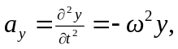 and so 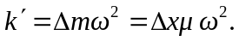

b) 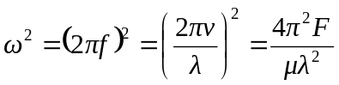

and so 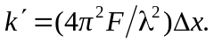 The effective force constant 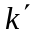 is independent of amplitude, as for a simple harmonic oscillator, and is proportional to the tension that provides the restoring force. The factor of 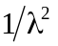indicates that the curvature of the string creates the restoring force on a segment of the string. More specifically, one factor of 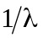is due to the curvature, and a factor of 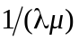 represents the mass in one wavelength, which determines the frequency of the overall oscillation of the string. The mass 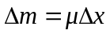 also contains a factor of 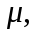and so the effective spring constant per unit length is independent of 